|  |  |  |
| --- | --- | --- |
| Sukkur_IBA_New_Logo | **Sukkur IBA University**  **Department of Computer Science** | **C:\Users\Saif Hassan\Downloads\CS logo (3).jpg** |

**DATA STRUCTURES**

**CountDistinctIntegers**

**Instructor: Saif Hassan**

**READ IT FIRST**

Prior to start solving the problems in this assignments, please give full concentration on following points.

1. WORKING – This is individual lab. If you are stuck in a problem contact your teacher, but, in mean time start doing next question (don’t waste time).
2. DEADLINE – 11th March, 2022
3. SUBMISSION – This assignment needs to be submitted in a soft copy.
4. WHERE TO SUBMIT – Please visit your LMS.
5. WHAT TO SUBMIT – Submit this docx and pdf file.

**KEEP IT WITH YOU!**

1. Indent your code inside the classes and functions. It’s a good practice!
2. It is not bad if you keep your code indented inside the loops, if and else blocks as well.
3. Comment your code, where it is necessary.
4. Read the entire question. Don’t jump to the formula directly.

I, \_**Amjad Ali**\_with student ID \_**191-21-0001**\_

Section \_**A**\_\_hereby declare that I do understand the instructions above and follow them. This is

my own work.

**Exercises**

**Task1 Description**

**…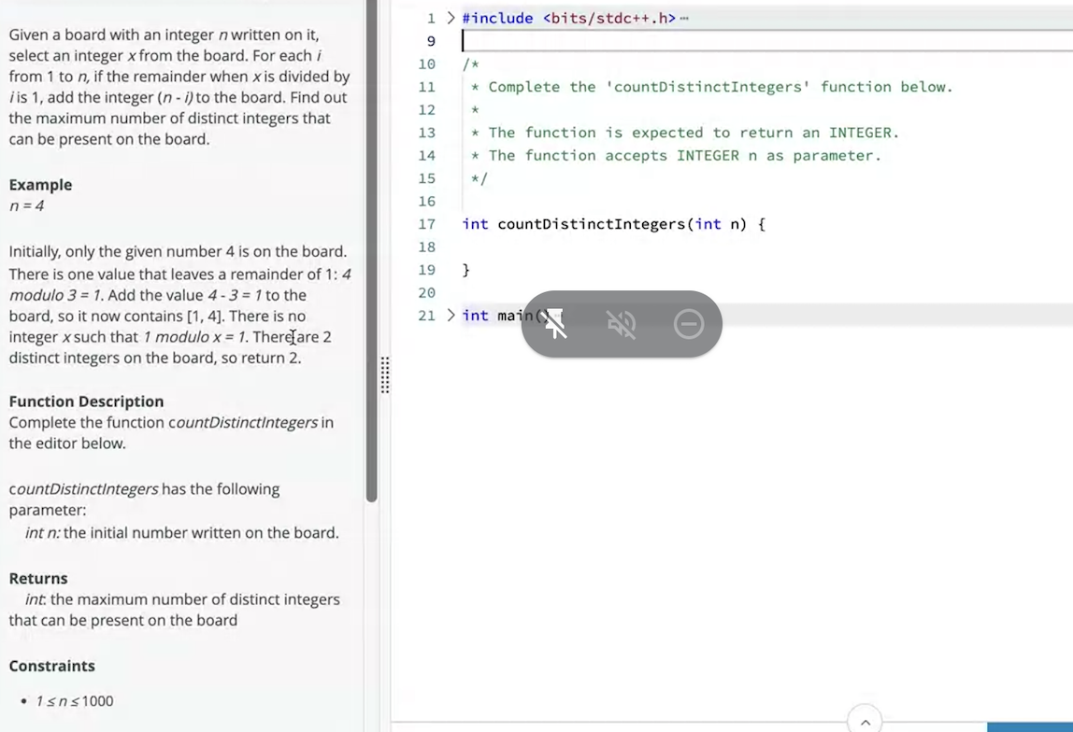**

Solution:

1. static HashSet<Integer> set=new HashSet<>();
2. public static int numberOfDistinctIntegers(int n){
3. set.add(n);
5. for(int i=1;i<n;i++)
6. {
7. if(n%i==1)
8. {
9. numberOfDistinctIntegers(n-i);
10. }
11. }
12. return set.size();
13. }

**Sample Input:**

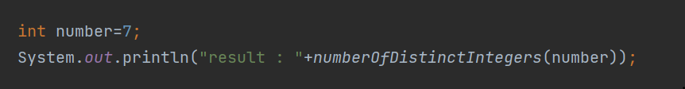**Sample Output**

